**中国正式禁止各类代币发行融资活动，虚拟货币价格随后暴跌**

编辑：徐雪 2017.9.4

“ICO在中国遭禁止，《公告》称，代币发行融资行为涉嫌非法集资、金融诈骗，传销等违法活动“

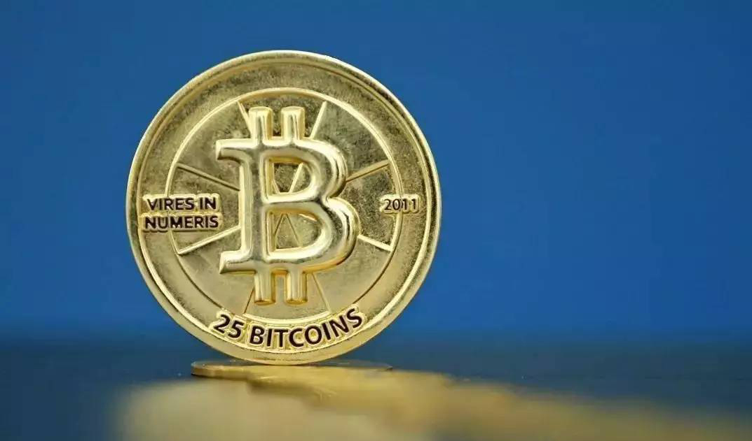

2017年9月4日下午，中国人民银行官网正式发布《中国人民银行 中央网信办 工业和信息化部 工商总局 银监会 证监会 保监会关于防范代币发行融资风险的公告》（以下简称《公告》），公告称，自公告发布之日起（9月4日），各类代币发行融资活动应当立即停止。同时，已完成代币发行融资的组织和个人应当做出清退等安排，合理保护投资者权益，妥善处置风险。有关部门将依法严肃查处拒不停止的代币发行融资活动以及已完成的代币发行融资项目中的违法违规行为。

《公告》指出，代币发行融资是指融资主体通过代币的违规发售、流通，向投资者筹集比特币、以太币等所谓“虚拟货币”，本质上是一种未经批准非法公开融资的行为，涉嫌非法发售代币票券、非法发行证券以及非法集资、金融诈骗、传销等违法犯罪活动。《公告》表示，代币发行融资中使用的代币或“虚拟货币”不由货币当局发行，不具有法偿性与强制性等货币属性，不具有与货币等同的法律地位，不能也不应作为货币在市场上流通使用。

今年以来，通过发行代币形式（ICO）融资的活动大量涌现，各种投机行为趁势而为，其中一些涉嫌从事非法金融活动，严重扰乱了经济金融秩序。近日关于ICO的监管猜测众说纷坛，整个环境被笼罩在迷雾之下，直至监管政策出台。而在过去几天，关于ICO涉嫌非法集资的报道，以及相关专项整治的出台，引起了币圈和链圈不小的地震，而最明显最直接的影响就是数字货币价格急剧大幅下跌。

公告发布后，各个ICO交流群（项目社区）中，多数准备入手ICO代币的投资者表示要“赶紧清仓！”，一些正在发起ICO的项目表示将按照国家法律法规进行退市退币，有的国外项目也发布公告不允许中国参与者继续参与，虚拟货币的价格自此出现大幅波动。

标签：ICO；虚拟货币；监管；《公告》

总浏览数：***

*【声明：文章为作者独立观点，不代表UNITIMES官网立场。欢迎转载，转载请务必注明来源。如有不当之处请多指教】*

**China Bans all Token Offering Financing Activities, Price of the Virtual Currencies Decline**

Editor：Xue Xu 4 Sept, 2017

*“Regulatory authorities said ICO is an unauthorized illegal fund-raising that may involve in illegal sale of tokens, financial fraud, pyramid schemes and other criminal activities.”*



On Sept. 4th, 2017, seven government authorities including the People’s Bank of China, Cyberspace Administration of China, Ministry of Industry and Information Technology of the People’s Republic of China, State Administration for Industry & Commerce of the People’s Republic of China, China Securities Regulatory Commission, China Banking Regulatory Commission and China Insurance Regulatory Commission have all come together to issue a Joint Statement, echoing the committee’s stance on how ICOs are a form of unauthorized illegal fund raising.

According to the Statement, all organizations and individuals are now prohibited from raising funds through any ICO activities. From the date of the Statement (Sep. 4), those who have completed ICOs should make arrangements for refunding and manage the risks properly. Relevant authorities will crack down the ongoing ICOs that refuse to stop.

The Statement defines ICO as a practice of unauthorized fundraising which may involve illegal sale of tokens, illegal issuance of securities, illegal fund-raising, financial fraud, pyramid schemes and other criminal activities. The Statement said that the tokens or“virtual currencies” used in ICOs are not issued by the authorized organizations, therefore they do not have the same legal status as the fiat currency, thus they cannot and should not be circulated and used as currencies in the market.

ICO financing activities have emerged in large numbers this year and were misused by ill-intentioned speculators. Some ICO projects are highly suspected of financial scams that disrupted the economic and financial order. Recently, people are waiting for the regulatory policy for ICOs and there were different speculations from the outside until the policy was formally released. In the last few days, the reports on ICOs have caused a stir in the virtual currencies and Blockchain field. People witnessed the most striking and direct consequence is the sharp decline of the prices of the digital currencies.

Following the release of the Statement, many investors said, “it’s time to sell out all my digital assets!!”. Some on-going projects announced that they would exit the market according to the national laws and regulations, the completed ICO projects will arrange the refunding affairs, and some oversea projects have also officially prohibited Chinese to participate in their token-sale activities. The prices of the virtual currencies have fluctuated wildly since then.

Tags：ICO； virtual currency；Regulatory policy；Statement

Total views：***

*【Declaration: Please indicate the source if repost the article in UNITIMES. Opinions expressed by Contributors belong to themselves.】*